Figure Legends
Figure S1. The boxplot of FPKM and TPM for mRNAs and miRNAs.
Figure S2. Analysis of alternative splicing events for mRNA.
Figure S3. Portions of small RNA types in the clean reads.
Figure S4. Size distribution of all miRNAs.

Table S1. Primers used in real-time quantitative PCR of different expression genes and miRNAs in ovaries samples

Table S1. Primers used in real-time quantitative PCR of different expression genes and miRNAs in ovaries samples
Gene Name | Primer Sequence | Amplicon | GenBank Accession Number
RHOA | F:GCAAACCGCATTGGTGCATT | 103 | XM_013201830.1
 | R:GGGCTTGCAAAGCAGCTCTA
RAB11FIP3 | F:AGACGGAGCTGGAGCAAGAGATC | 138 | XM_013176835.1
 | R:CGGAGAAGGAGGCTGAGAAGAGG
NR0B1 | F:GCCTGGACATCAGCACCAAG | 112 | XM_013192667.1
 | R:GCTTCCCTCTGCAGTCCTTC
RPS24 | F:TCGCTTCCCATCAAGGAGTC | 376 | XM_013174975.1
 | R:GAACAGGGGCAGACACGATT
TNFRSF1A | F:GGAAGACGCAGCTACCAGACAATC | 140 | XM_013196441.1
 | R:ACGCCGATGCTCCAACTCAATTC
SFRP4 | F:GTCTTCGATGCCGATTCCTCTGTC | 115 | XM_013194296.1
 | R:CGAGCGCCACTCATAGCACATG
MGP | F:CACTCCTGGCTACCTTGGTC | 239 | XM_013196508.1
 | R:GTGGCGAGAAGCGTACAGT
ZFYVE9 | F:TCCGCCTTCTCGTCGTCTGTC | 134 | XM_013176304.1
 | R:CCGCTCCTCCTGGTGGTGTAG
AMH | F:GCTGCTACTCGCCTCCTCTCC | 161 | XM_013196337.1
 | R:TCCTGGTCCTGGTCCATCTTCATC
β-actin | F:GCCCTCTTCCAGCCATCTTT | 373 | XM_013174886.1
 | R:TGGGTGTTGGTAACAGTCCG
gga-miR-499-5p | F:TTAAGACTTGTAGTGATGTTTAG | 23 | MIMAT0003367
gga-miR-375 | F:TTTGTTCGTTCGGCTCGCGTTA | 22 | MIMAT0003362
gga-miR-15b-5p | F:TAGCAGCACATCATGGTTTGCA | 22 | MIMAT0001154
gga-miR-99a-3p | F:CAAGCTCGCTTCTATGGGTCT | 21 | MIMAT0006781
gga-miR-133a-5p | F:AGCTGGTAAAATGGAACCAAATC | 23 | MIMAT0026509
gga-miR-133b | F:TTGGTCCCCTTCAACCAGCTA | 21 | MIMAT0001138
gga-miR-365b-5p | F:AGGATTTTTAGGGGCATTATGA | 22 | MIMAT0025674
gga-miR-2131-5p | F:ATGCAGAAGTGCACGGAAACAGCT | 24 | MIMAT0011207
gga-miR-27b-5p | F:AGAGCTTAGCTGATTGGTGAACA | 23 | MIMAT0026547
U6 | F:GGAACGATACAGAGAAGATTAGC | 23
 | R:TGGAACGCTTCACGAATTTGCG
* The 3' primer of microRNA was used in accordance with the instructions of the kit, and the primer sequence was not provided by the company on account of trade secret.

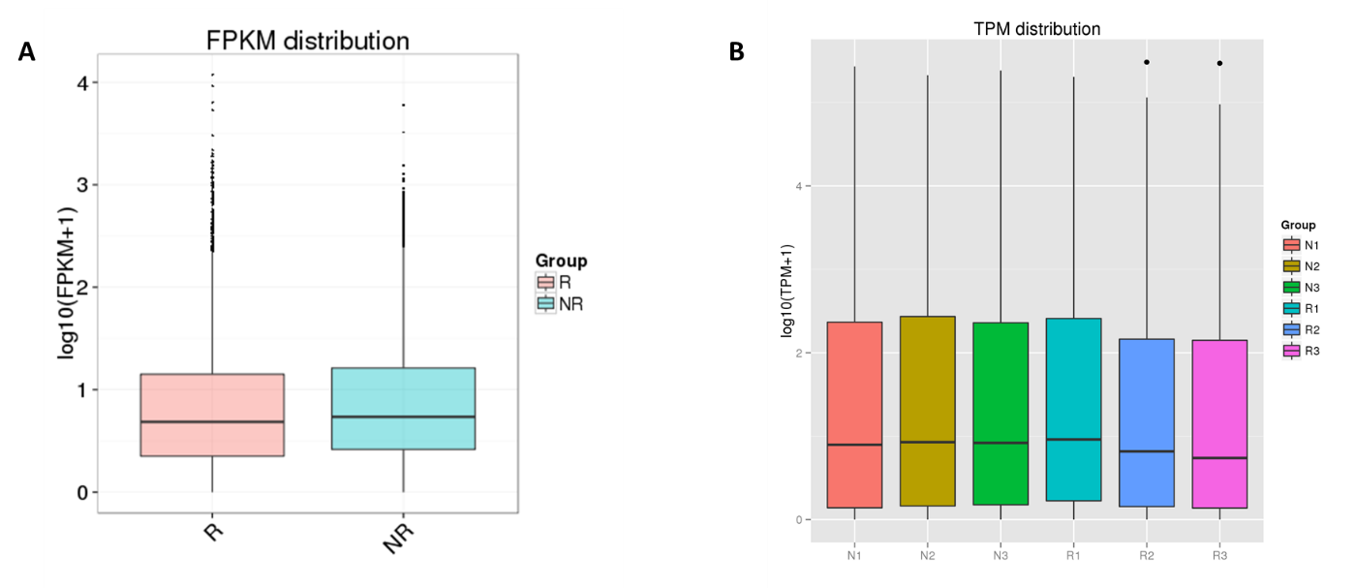
Figure S1. The boxplot of FPKM and TPM for mRNAs and miRNAs. (A) mRNAs; (B) miRNAs.

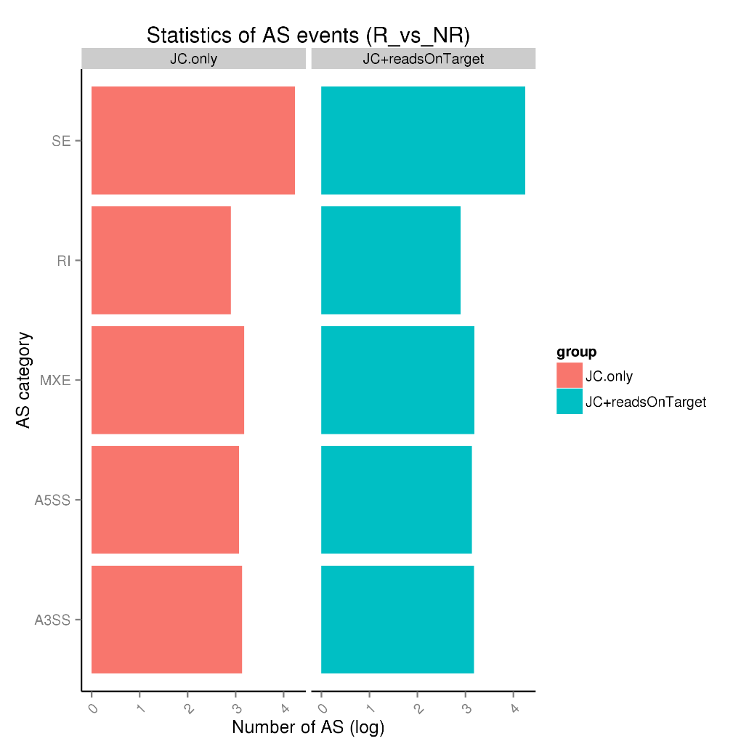
Figure S2. Analysis of alternative splicing events for mRNA. Definitions: JC.only: Junction Count only. JC+reads On Target: Reads on target and junction counts. SE: Skipped exon. MXE: Mutually exclusive exon. A5SS: Alternative 5' splice site. A3SS: Alternative 3' splice site. RI: Retained intron.

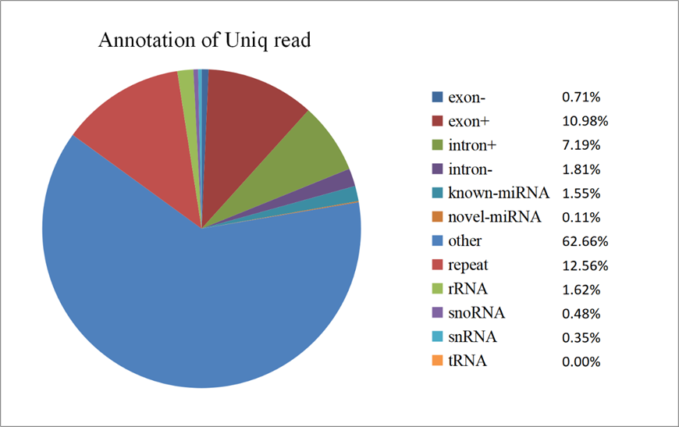
Figure S3. Portions of small RNA types in the clean reads. The percent of miRNA is approximately 64.32%, and the other 35.68% included rRNA, snRNA, snoRNA, tRNA, simple repeats, exon sense/antisense and intron sense/antisense.

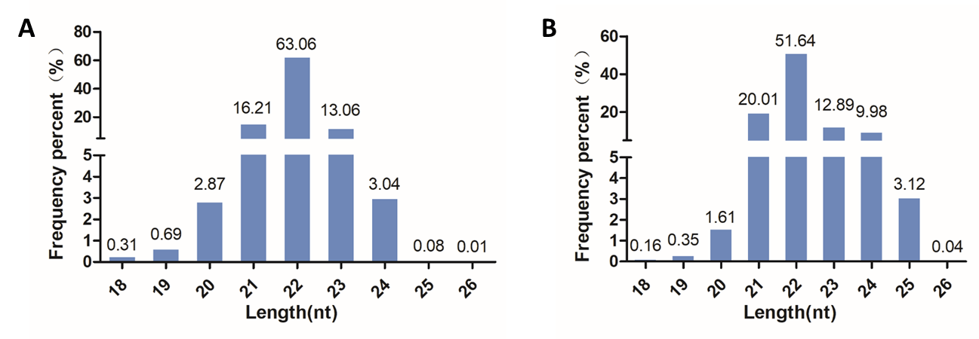
Figure S4. Size distribution of all miRNAs. (A) Known miRNAs; (B) novel miRNAs. The X-axis depicts their length (nt), and the Y-axis represents frequency (%).

